A Once-in-a-Generation Blood Moon Signal Just Landed on the Most Volatile Year in the Chinese Zodiac
- Mar 2
- 5 min read
On March 3rd, a blood moon rises during the first lunar month of the Chinese New Year. That alone would be significant. It's only happened twice in the last hundred years. The last time was 2007, a year that delivered record market highs, a technological revolution, and the beginning of a global financial crisis, all at once.

But 2025 adds a layer that 2007 didn't have. This is a Fire Horse year. Fire years amplify everything. The highs go higher. The lows go lower. And the Fire Horse is the fastest, wildest animal in the cycle. The rarest signal in the Chinese calendar just got amplified by the most intense year in the zodiac.

I'm the Firepig. I was born in the Fire Pig year of 1947, and I've been studying Chinese astrology for decades. The Fire Pig is full of contradiction: generous but explosive, abundant but reckless. When 2007 came around, the first Fire Pig year since my birth, I called it "my year" and predicted extremes in every direction. I was right.
Now I'm watching the same rare signal appear again, this time amplified by the Fire Horse. I'll be honest with you. I'm more nervous and more excited than I was before.

What Is a Blood Moon?
A blood moon is a lunar eclipse that turns the moon red. Scientifically, it's Earth's shadow filtering sunlight through the atmosphere. Straightforward stuff. But symbolically, across thousands of years of human civilization, it's anything but.

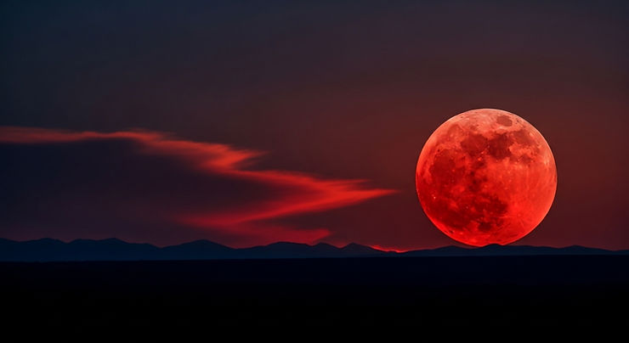
Blood Moon Rising

Why Cultures Around the World Take Notice
In Chinese cosmology, a lunar eclipse was traditionally described as a dragon devouring the moon. People would bang drums and make noise to scare it away. The first lunar month is supposed to be about renewal, fresh starts, and good fortune. An eclipse during that window was historically read as a warning sign for leadership, a disruption of harmony between Heaven and Earth, a signal that balance needs restoring.

Here's an interesting twist: red is normally a lucky color in China. But a red moon from an eclipse isn't "festival red." It's cosmic. Ambiguous. Not something you celebrate.
Vietnam shares those roots. Because the first lunar month overlaps with Tết, a time for luck, new beginnings, and family alignment, an eclipse traditionally reads as a disturbance in that clean slate. Older generations may still treat it as a moment to pause and reflect rather than push forward.

Japan historically saw eclipses as omens, especially in court culture during the Heian period. Celestial irregularities could be interpreted as signals about political instability. Korea's folklore describes celestial dogs trying to bite the moon, causing eclipses. In Hindu cosmology, eclipses are linked to Rahu and Ketu, shadow entities that swallow celestial bodies, and are still taken seriously across many communities today.

The pattern across cultures is remarkably consistent. Eclipses signal imbalance. The first lunar month signals renewal. When you combine them, you get symbolic tension: a new beginning with a cosmic interruption.

You don't have to believe in any of this to notice that human beings across continents and centuries independently arrived at the same conclusion. That's not superstition. That's pattern recognition on a civilizational scale.

The Fire Horse Amplifier
Now here's where it gets really interesting.

The Chinese zodiac doesn't just cycle through twelve animals. Each year also carries one of five elements: wood, fire, earth, metal, water. Fire years don't do anything halfway. They carry energy for both catastrophic events and extremely favorable, auspicious happenings. The Fire Horse in particular is known for speed, intensity, and volatility.
A blood moon in the first lunar month is the signal. The Fire Horse year is the amplifier. When you put them together, you get synergy. Not the corporate buzzword kind. The kind where forces compound and accelerate. A fast-paced, volatile year loaded with opportunity for both great success and great disaster.

I'll put it simply: this is not a year for the timid. But if you like excitement, you're going to get it.

And look, the year is barely two weeks past the Lunar New Year and the evidence is already stacking up. Military conflict escalating across the Middle East. Political upheaval in multiple regions. We were snowed in here in Indianapolis. Broadway was shut down for a couple of days in New York City. Rhode Island had the largest snowfall in the history of the state. The pace of extreme events is not normal, and we're just getting started.

The 2007 Parallel: When the Fire Pig Delivered on Its Promise

The only other time a blood moon fell in the first lunar month of the Chinese New Year in the last hundred years was 2007. That was a Fire Pig year. My year.

I was born in 1947, the last Fire Pig year before that one. Sixty years between them. So when 2007 came around, I knew what was coming. The Fire Pig is full of contradiction. Generous and destructive. Abundant and reckless. I predicted the year would deliver extremes in every direction, and it did.

On the high side, the S&P 500 hit its pre-crash peak in October at 1,565. The iPhone launched in June and rewired consumer expectations for computing overnight. The Nobel Peace Prize went to the IPCC and Al Gore for advancing climate awareness. Confidence was everywhere.

On the low side, the economy was already quietly rolling over. BNP Paribas froze subprime funds in August, and interbank lending seized up. The Fed cut rates 50 basis points in September, the kind of emergency move that signals something is breaking even when the headlines still sound optimistic. By December, the recession had officially begun, though most people wouldn't feel it until 2008.

Higher highs and lower lows. That was 2007's signature. The contradiction was the feature, not the bug. Markets peaked while the financial system's pipes were clogging. The future of technology arrived (iPhone) while the old world shipped its last gasp (Windows Vista). Arctic sea ice hit a record low while the world was just starting to treat climate change as a mainstream issue.

None of that surprised me. The Fire Pig contains those contradictions by nature. 2007 was simply the Fire Pig being the Fire Pig, on a global stage, with a blood moon lighting the way.

2025 is a different animal. The Fire Horse is faster, wilder, harder to control. And this time the signal isn't just present. It's amplified.

What This Means for You

You don't have to be a student of Chinese astrology to use this information. Think of it as a framework for how to approach a year that's already showing signs of being anything but average.

Volatile years reward people who pay attention. They reward preparation. They punish passivity and complacency. The people who thrived in 2007 weren't the ones who ignored the signals. They were the ones who saw both the risk and the opportunity and positioned accordingly.

If you're running a business, leading a team, or making big decisions this year, watch for the contradictions. When everything looks great on the surface but the underlying systems feel shaky, that's your signal. When disruption is everywhere, that's where the openings are.

Two times in a hundred years. The blood moon rises March 3rd. The Fire Horse is already running. Being a fire sign myself, I'm looking forward to it.

